Ezekiel John R. Libao
Exercise 1:
<!DOCTYPE html>
<html lang="en">
<head>
<meta charset="UTF-8">
<title>Exercise 1: Array Sum</title>
</head>
<body>
<h2>Sum of Array Elements</h2>
<p id="output"></p>

<script>
// Start execution [cite: 12]
// Create the array with 6 elements [cite: 13]
var numbers = [10, 20, 30, 40, 50, 60];
var sum = 0;

// Calculate the sum of array of integers using for loop [cite: 14]
for (var i = 0; i < numbers.length; i++) {
sum += numbers[i];
}

// Print the value of sum [cite: 15]
console.log("Sum: " + sum); // Check console
document.getElementById("output").innerHTML =
"Array: [" + numbers + "]<br>" +
"The sum is: " + sum;
</script>
</body>
</html>

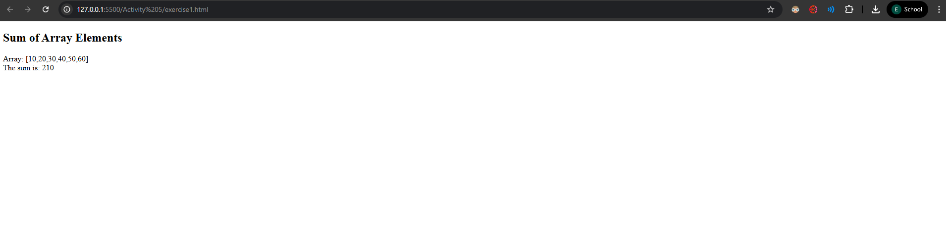Exercise 1 Screenshot:

Exercise 2:
<!DOCTYPE html>
<html lang="en">

<head>
<meta charset="UTF-8">
<title>Exercise 2: Leap Year</title>
</head>

<body>
<h2>Leap Year Checker</h2>
<button onclick="leapYear()">Check a Year</button>

<script>
// Declare and define the function leapYear() [cite: 21]
function leapYear() {
var year = prompt("Please enter a year:");

// Using conditional constructs to check leap year [cite: 22]
if ((year % 4 === 0 && year % 100 !== 0) || (year % 400 === 0)) {
// Show the result using 'alert' dialog box [cite: 23]
alert(year + " is a Leap Year.");
} else {
alert(year + " is NOT a Leap Year.");
}
}
</script>
</body>

</html>

Exercise 2 Screenshots:
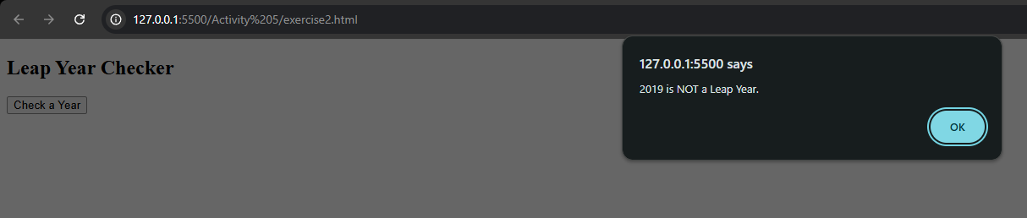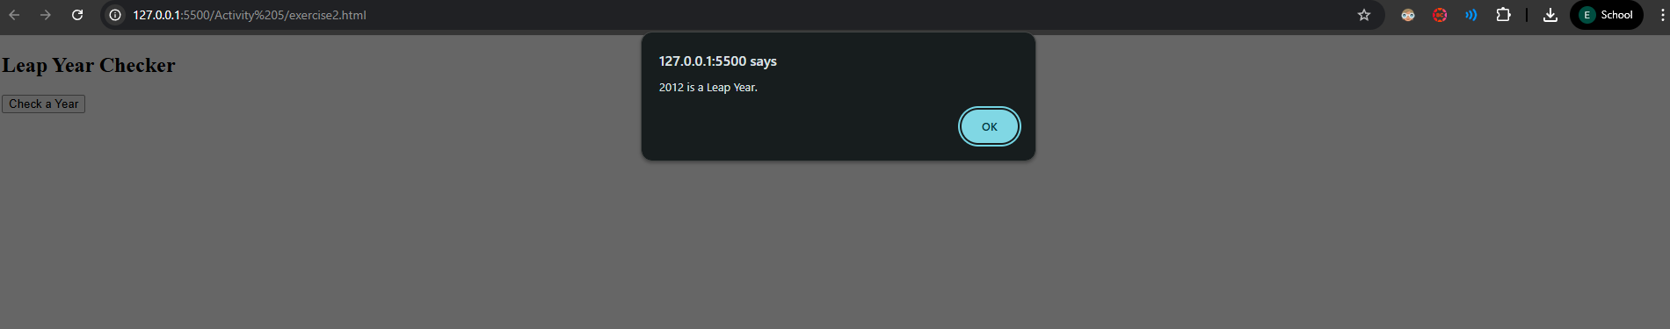
Exercise 3:
<!DOCTYPE html>
<html lang="en">

<head>
<meta charset="UTF-8">
<title>Exercise 3: Odd or Even</title>
</head>

<body>
<h2>Odd or Even Loop (0-15)</h2>
<div id="result"></div>

<script>
var output = "";
// Using for loop and conditional construct [cite: 31]
for (var i = 0; i <= 15; i++) {
if (i % 2 === 0) {
output += i + " is even<br>";
} else {
output += i + " is odd<br>";
}
}
// Print the output [cite: 32]
document.getElementById("result").innerHTML = output;
</script>
</body>

</html>

Exercise 3 Screenshots:
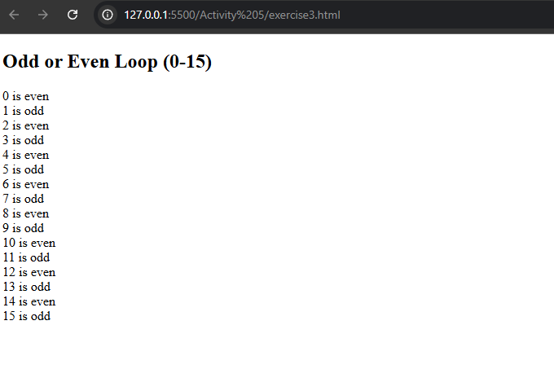
Exercise 4:
<!DOCTYPE html>
<html lang="en">

<head>
<meta charset="UTF-8">
<title>Exercise 4: Calculator</title>
<style>
body {
margin: 30px;
}
</style>
</head>

<body>
<h2>Multiply and Divide</h2>
<form>
1st Number : <input type="number" id="num1"><br><br>
2nd Number: <input type="number" id="num2"><br><br>
<input type="button" onClick="multiplyBy()" Value="Multiply">
<input type="button" onClick="divideBy()" Value="Divide">
</form>

<p>The Result is: <br>
<span id="result"></span>
</p>

<script>
// Declare and define function multiplyBy() [cite: 39]
function multiplyBy() {
var n1 = document.getElementById("num1").value;
var n2 = document.getElementById("num2").value;
document.getElementById("result").innerHTML = n1 * n2;
}

// Declare and define function divideBy() [cite: 39]
function divideBy() {
var n1 = document.getElementById("num1").value;
var n2 = document.getElementById("num2").value;
document.getElementById("result").innerHTML = n1 / n2;
}
</script>
</body>

</html>

Exercise 4 Screenshots:
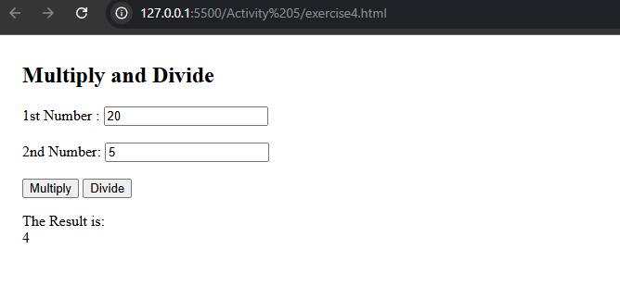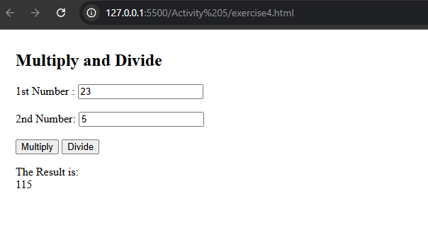

Exercise 5:
<!DOCTYPE html>
<html lang="en">

<head>
<meta charset="UTF-8">
<title>Exercise 5: Temp Converter</title>
</head>

<body>
<h2>Temperature Converter</h2>

<p>
<label>Fahrenheit:</label>
<input id="inputFahrenheit" type="number" placeholder="Fahrenheit" oninput="FartoCen(this.value)"
onchange="FartoCen(this.value)">
</p>
<p>Celsius: <span id="outputCelsius"></span></p>

<hr>

<p>
<label>Celsius:</label>
<input id="inputCelsius" type="number" placeholder="Celsius" oninput="CentoFar(this.value)"
onchange="CentoFar(this.value)">
</p>
<p>Fahrenheit: <span id="outputFahrenheit"></span></p>

<script>
// Declare and define function FartoCen()
function FartoCen(valNum) {
valNum = parseFloat(valNum);
document.getElementById("outputCelsius").innerHTML = (valNum - 32) / 1.8;
}

// Declare and define function CentoFar()
function CentoFar(valNum) {
valNum = parseFloat(valNum);
document.getElementById("outputFahrenheit").innerHTML = (valNum * 1.8) + 32;
}
</script>
</body>

</html>

Exercise 5 Screenshots:
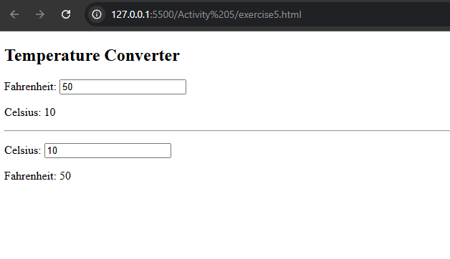

Exercise 6:
<!DOCTYPE html>
<html lang="en">

<head>
<meta charset="UTF-8">
<title>Exercise 6: Reverse Number</title>
</head>

<body>
<h2>Reverse a Number</h2>
<input type="number" id="userNumber" placeholder="Enter number">
<button onclick="rev_num()">Reverse</button>
<p id="output"></p>

<script>
// Declare and define the function rev_num()
function rev_num() {
// Get the input num from the user [cite: 56]
var n = document.getElementById("userNumber").value;

// Logic to reverse string/number
var reversed = n.toString().split("").reverse().join("");

// Print the result [cite: 57]
document.getElementById("output").innerHTML = "Reversed: " + reversed;
}
</script>
</body>

</html>

Exercise 6 Screenshots:
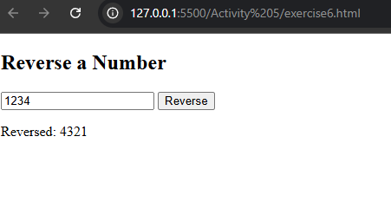

Exercise 7:
<!DOCTYPE html>
<html lang="en">

<head>
<meta charset="UTF-8">
<title>Exercise 7: Palindrome</title>
</head>

<body>
<h2>Palindrome Checker</h2>
<input type="text" id="str" placeholder="Enter string">
<button onclick="myFunction()">Check</button>
<p id="result"></p>

<script>
// Declare and define myFunction() (as the entry point)
function myFunction() {
var string = document.getElementById("str").value;
var isPal = checkPalindrome(string);

if (isPal) {
document.getElementById("result").innerHTML = "It IS a palindrome.";
} else {
document.getElementById("result").innerHTML = "It is NOT a palindrome.";
}
}

// Declare and define checkPalindrome()
function checkPalindrome(str) {
// Remove non-alphanumeric chars and lowercase for better checking
var re = /[^A-Za-z0-9]/g;
str = str.toLowerCase().replace(re, '');
var reversedStr = str.split('').reverse().join('');
return reversedStr === str;
}
</script>
</body>

</html>

Exercise 7 Screenshots:
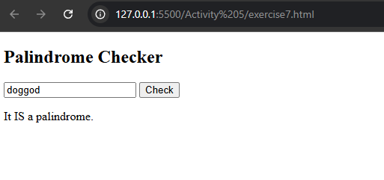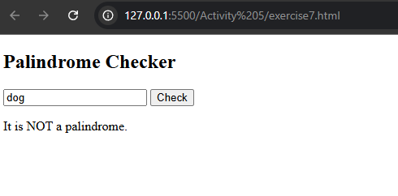

Exercise 8:
<!DOCTYPE html>
<html lang="en">

<head>
<meta charset="UTF-8">
<title>Exercise 8: Uppercase Check</title>
</head>

<body>
<h2>First Character Uppercase Check</h2>
<input type="text" id="textInput" placeholder="Enter text">
<button onclick="runCheck()">Check</button>
<p id="output"></p>

<script>
function runCheck() {
var str = document.getElementById("textInput").value;
upper_case(str);
}

// Declare and define the function upper_case()
function upper_case(str) {
var regexp = /^[A-Z]/;
if (regexp.test(str)) {
document.getElementById("output").innerHTML = "First character is uppercase.";
} else {
document.getElementById("output").innerHTML = "First character is NOT uppercase.";
}
}
</script>
</body>

</html>

Exercise 8 Screenshots:
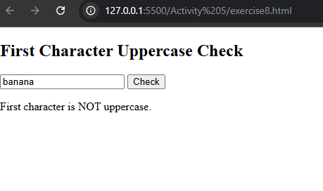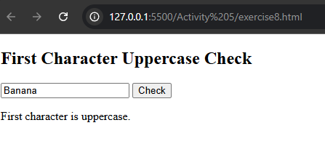

Exercise 9:
<!DOCTYPE html>
<html lang="en">

<head>
<meta charset="UTF-8">
<title>Exercise 9: Background Color</title>
</head>

<body>
<h2>Change Background Color</h2>
<p>Click the button to change the paragraph background below.</p>

<button onclick="set_background()">Set Background</button>

<p id="myParagraph">
This is a sample paragraph. Watch my background change!
</p>

<script>
// Declare and define the function set_background() [cite: 80]
function set_background() {
var para = document.getElementById("myParagraph");
para.style.backgroundColor = "yellow";
para.style.padding = "10px";
para.style.border = "1px solid black";
}
</script>
</body>

</html>

Exercise 9 Screenshots:
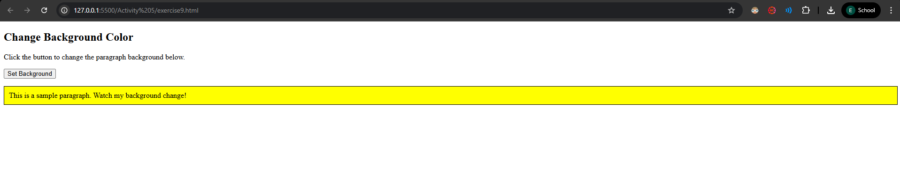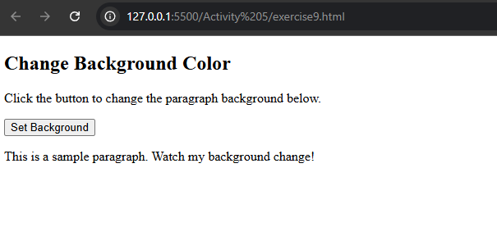
Exercise 10:
<!DOCTYPE html>
<html lang="en">

<head>
<meta charset="UTF-8">
<title>Exercise 10: Mobile Validation</title>
</head>

<body>
<h2>Mobile Number Validation</h2>
<input type="text" id="mobile" placeholder="Enter 10 digit number">
<button onclick="MobileNoValidation()">Validate</button>
<p id="message"></p>

<script>
// Declare and define the function MobileNoValidation() [cite: 88]
function MobileNoValidation() {
// Get the input mobile no from the user [cite: 89]
var mobile = document.getElementById("mobile").value;
var msg = document.getElementById("message");

// Basic check for 10 digits
var pattern = /^\d{10}$/;

if (pattern.test(mobile)) {
msg.innerHTML = "Valid Mobile Number";
msg.style.color = "green";
} else {
msg.innerHTML = "Invalid Mobile Number (Must be 10 digits)";
msg.style.color = "red";
}
}
</script>
</body>

</html>
Exercise 10 Screenshots:
